

**WOLDIA UNIVERSITY**

**FACULTY OF TECHNOLOGY DEPARTMENT OF COMPUTER SCIENCE**

**Final Proposal I**

**A Project documentation on web based human resource management system for Woldia University**

**By:**

**Name ID Email Phone Number**

1. **Daniel Tefera ------- FOT(R)1699/08…. danieltefera14@gmail.com........0919319791**
2. **Biruk Debebe ------- FOT(R)1665/08…. birukdebebe432@gmail.com.....0946630304**
3. **Alelign Kebede ----- FOT(R)1649/08….** [**alexof21@gmail.com**](mailto:alexof21@gmail.com) **…………..0927412579**
4. **Kasim Misganaw ---FOT(R)1806/08….** [**ksmm0511@gmail.com**](mailto:ksmm0511@gmail.com) **…….….0935261724**
5. **Ayalnesh Tsehaye --FOT(R)1667/08…..ayalinesh12@gmail.com ……….0939300187**
6. **Habtam Dessie ----- FOT(R)1778/08…..habtamdessie1@gmail.com ……0988305981**

**Advisors**

Advisor: Demeke Getaneh (MSc)

Co-Advisor: Fasil Alemu (BSc)

**December 11, 2018**

**Woldia, Ethiopia**

**Table Contents**

**Summary** 3

**1.** **Introduction** 3

**1.1** **Background of Woldia University** 3

**1.2** **Motivation** 4

**1.3** **Statement of the problem** 4

**1.4** **Objective** 5

**1.4.1** **General objectives** 5

**1.4.2** **Specific objectives** 5

**1.5** **Literature review** 5

**1.6** **Scopes and limitations of the project** 5

**1.6.1** **Scopes of the project** 5

**1.6.2** **Limitations of the project** 6

**1.7** **Methodology** 6

**1.7.1** **Data gathering techniques** 6

**1.7.2** **System analysis and design methodology** 7

**1.8** **System development model** 7

**1.9** **System development tools** 8

**1.9.1** **Hardware tools** 8

**1.9.2** **Software tools** 8

**1.9.3** **Documentation tools.** 9

**1.10** **Significant of the project** 9

**1.11** **Feasibility of the project** 9

**1.11.1** **Technical feasibility** 9

**1.11.2** **Operational feasibility** 10

**1.11.3** **Economic feasibility** 10

**1.12** **Work break down structure and schedule** 11

**1.12.1** **Work break down** 11

**1.12.2** **Schedule** 11

**References** 12

# **Summary**

In current manual system, Woldia University human resource management system provides several activities. It performs register new employee, performing leave application for the employees, performing placement and procurement, post announcement and many other. Those activities perform manually. And we are trying to solve those problems appear in the above activities such as it is time consuming, lack of accuracy, lack of security, improper use of resources, difficulty in recording and managing the employees information and time taking report generation and many others by making the manual working environment in to web based system. After our system is implemented it minimizes the work load of employees in the WDU human resource management office. And also it makes technically easier to use the system by the customer so, the purpose of this proposed system is relevant.

# **Introduction**

Now a day most business applications are changed into web based system. Web based system is a system that enables the user to do their works simply, accurately, effectively and efficiently. This helps to increase the qualities of the work, reduces the complexities of tasks, keeps the security of data in most advantageous condition, data transfer makes more easily, provide quality reports , provide faster services to the customers , and the like.

Human resource management system is a system that is used to manage human resource and its information available in the organization.

This project is designed to maximize employee’s performance in service of their employer’s strategic objectives.

The main function of WDU human resource management system is to manage employee profile or biography of the employee, post announcement, manage accounts, performing placement, register both applicants and employees profile, performing leave application for the employees and the like. So this system stands for those services that the organization provides to their employees and applicants.

Since it is automated (web based) it reduces a lot of costs, work over load and it minimizes the space used to store the data and also it provides faster customer service.

## **Background of Woldia University**

Woldia University was established through the council of ministers regulation no 223/2011 issued on May 26, 2004. Currently, the total area of the university is 196 hectares of land. Woldia University has two campuses, namely, the main campus called Woldia University and the other one is mersa campus of agriculture. It is 30 kms far from the main campus. The first batch of students, numbering 599, has been admitted to the university on Dec 10/2004 in fabulous reception ceremony involving invited guests city residents, representatives of different zone & Woreda administrative offices and university’s community. Students have been placed in to four faculties and 12 departments. In its second year of operation, the university admitted over 1457 new students. The number of faculties grew in to six, the two newly added being the faculty of Agriculture and pedagogical and behavioral science faculty. Likewise, the number of departments doubled in to 24. Currently, the university has a student population of over 4300. The university is anticipated to contain a student population of 11,000 over a period of five years. More than 150 blocks are planned to be erected in different phases with in the specified period. As the number of students and academic branch is increasing the employees who work in the university like teachers and administrative workers is also increase so, to manage those employees the work load of Woldia University human resource management office is become strongly hard that is why we are developing this web based system for the office.

## **Motivation**

Even if this project title is selected by the department but we are very interested after we are seeing the working environment. Means that their working processes are not match with the current technologies. All their works are done manually and they have no databases they simply stores their files in a big lockers. Surprisingly the locker that they used to stores different files occupy many space since they store many paper files. Assume if in this way they continues to stores their file, they may have to change their offices since the documents need additional space. And there are many other difficulties like it is not safe for documents security, also it is not good for customer’s satisfaction and the like. And also the other motivation for us is to fulfill our bachelor degree. So, we are very happy to solve these and other problems.

## **Statement of the problem**

Now, Woldia University human resource management office provides several activities. It performs register new employee, performing leave application for the employees, performing placement and procurement, post announcement and others. Those activities perform manually.

Some challenges regarding to the current systems are:-

* **Time consuming**: - it takes time to register employees profile, to perform leave employees process, to generate reports, and for other operation.
* **Shortage distribution of information**: - information’s like announcement, may be not reach in to customers at the right time.
* **Lack of accuracy and security** :- the current manual system may leads to different mistakes and also it is not secured due to the files are stored in paper for instance if there is accident like fire or thief the full data may be lost.
* **Difficult to manage employee information**: - it is difficult to register, search, update, employee’s information.
* **Problem of work efficiency**: - The current manual system is not efficient due to many reasons like the customer may not be satisfied because of paper based system. It may take much amount of time to serve customer’s
* **Improper use of resources**:- this manual system takes many resources like paper, pen, human power, and many other resources will be improperly consumed
* **Difficulties in record management:** - Registration is difficult in the current manual system means that it takes time and other resources.

## **Objective**

### **General objectives**

The general objectives of this project is to develop automated human resource management system for Woldia University.

### **Specific objectives**

The specific objectives of our project are-

* To collect requirements.
* To analyze and study the existing manual system.
* Design the system that will solve the current problems and provide reliable functionalities.
* To Study the requirement analysis.
* To design the interface.
* To implement the proposed system in effective way by Php.

## **Literature review**

Human resource management system is done in different universities even in our universities before but they are unable to touch best requirements of the organization, unable to make the system secure, unable to make the system interactive and attractive or user friendly for the end user. May be it comes from time constraints. So we are trying to cover those problems and limitations means that to touch the rest requirement and make the rest of the system attractive, user friendly and reliable. Human resource management system is implemented in different universities like Addis Abeba University, Addis abeba science and Technology University since it is basic thing for one’s institution to facilitate their works, but still their system have problems like the system has not user friendly interface, the system is developed for only literate people means that since is support only English language a user who don’t knows English language may not use the system properly, so this and other problems enforced to do this system again for our university human resource management system office.

## **Scopes and limitations of the project**

### **Scopes of the project**

* Announcement of notice online.
* Online Registration of Applicants.
* Register and manage the employee profile.
* Provide leave employee process.
* Support local language.
* Register employee training and training event.
* Recruiting employee.
* Registering new Employee.
* Generating report like Human resource report, recruitment report, training report, and other reports will be generated.

### **Limitations of the project**

It is a great trouble for us to get an information about the current manual human resource management system since it helps us what is the working environment looks like. And the other is it is too wide to include all functionality of human resource office due to time constraints.

## **Methodology**

Here we are using different methodologies for data gathering and for system analysis and design.

### **Data gathering techniques**

#### **Interview**

We will find information’s from woldia university human resource management office employees by asking different questions. Among the questions here are some:

* What kind of system the organization has used?
* How the existing manual system works?
* What is the duty of the institution workers?
* What are the problems of the existing system?
* What are the main responsibilities of the organization?
* What is the steps to recruit new employees?

#### **Discussion**

This is one of the technique in which we have seated together and discussed on the project how we can perform the system. Here we will discuss what jobs of the WDU HRM office will be changed in to the system and also we will discuss to find the difficulties in working environment and how to solve or to minimize.

#### **Observation**

Observing the real environment is quite important tool to realize the existing problems and business processes. Assessing and analyzing the overall system has been carried out by observing the current manual working system. We will observe WDU Human Resource management office to look at how they operate their tasks, how their system works, how data are handled and information of customers is kept in the system.

#### **Documents**

We will refer different documents that published by WDU human resource office as well as the university like brochures, and different papers that are posted in the Woldia university human resource management office’s wall. And also the existing documents such as forms, guidelines, reports are our main source of data.

### **System analysis and design methodology**

For the system analysis and design part there are two models. Those are, structured and object oriented approach. From those this project uses object oriented approach because it is efficient to show how the data is organized, it also shows clearly the definition of the data of the system in addition to this it provides improved quality, real-world modelling, high code reusability. In general, the project uses the object oriented paradigm to develop the system. Especially by using diagrams like Software architecture diagram, and system decomposition diagrams.

* Object oriented analysis allow reusability: one can easily study existing object to see if they can be reused.
* Software complexity managed easily and Object–oriented systems can be easily upgraded.
* Reduce communication complexity between system developer and client because it allows system developer to design both the static and dynamic part of the system.

Generally object oriented principle (data abstraction, data encapsulation, inheritance and polymorphism) make this method powerful than other method of system development and we enforced to select this system development approach.

## **System development model**

The development model methodology that we have used is Incremental model among other models because of it enables us to go forward and backward as it is necessary.

The reason why we use Incremental development is because of those important benefits:

1. The cost of accommodating changing customer requirements is reduced. The amount of analysis and documentation that has to be redone is much less than is required with the waterfall model.

2. It is easier to get customer feedback on the development work that has been done. Customers can comment on demonstrations of the software and see how much has been implemented. Customers find it difficult to judge progress from software design documents.

3. More rapid delivery and deployment of useful software to the customer is possible, even if all of the functionality has not been included. Customers are able to use and gain value from the software earlier than is possible with a waterfall process.

4. Early increments act as a prototype to help elicit requirements for later increments.

5. Lower risk of overall project failure.

6. The highest priority system services tend to receive the most testing.

7. Error reduction: The core modules are used by the customer from the beginning and therefore these get tested thoroughly. This reduces chances of errors in the core modules of the final product, leading to greater reliability of the software.

8. Incremental resource deployment: This model obviates the need for the customer to commit large resources at one go for development of the system. It also saves the developing organization from deploying large resources and manpower for a project in one go.

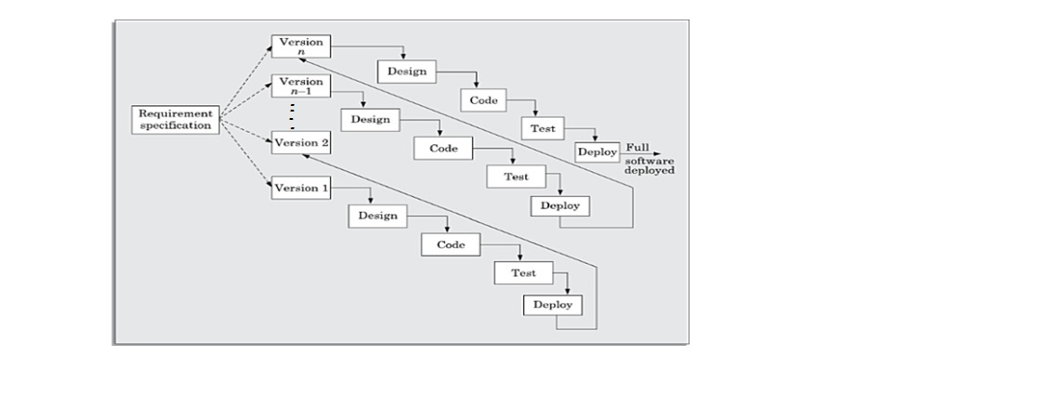

## **System development tools**

### **Hardware tools**

* Computer Desktop and laptop to develop our project means for documentation and implementation.
* Printer to print our project documents.
* Data storage like flash, CD, for backup

### **Software tools**

* Editor like Notepad ++, sublime those are editors that we will use them to edit our source code.
* Browser like Google chrome, Mozilla Firefox, internet explorer, baidu spark, UC browsers and others are a client interface that display information to the users retrieved from the server and we will use them for testing or to run our projects.
* Microsoft word is a free application software developed by the Microsoft Company and we will use it for preparing our project documentation.
* Microsoft Power point is also a open source application software developed by the Microsoft company and we will use it for preparing our project presentation.
* Edrawmax and Microsoft Visio it an application software that helps us to draw different UML diagrams.

### **Documentation tools.**

* Microsoft Office 2013

**Development tools**

* Php to develop back end of our program.
* Apache server since it runs on 67% of all web server in the world.
* Database namely MySQL to store the organization permanent data’s.
* Java script frame works namely jQuery to validate different forms
* CSS framework namely bootstrap to make our user interface interactive.

## **Significant of the project**

* The work load of the employees will be reduced.
* Easy to search employees profile or information.
* Data will be secured for the users.
* It will save time, man power and resource like papers filling to be registered.
* Easy to generate a report daily, weekly or monthly.
* It will be easy to post announcement and different notification.
* Higher speed of retrieval and processing of data.
* Giving information to users in Local language (Amharic).
* Users will get information and news from the office at anywhere and at any time.

## **Feasibility of the project**

### **Technical feasibility**

At the implementation stage, we should use the latest technology development tools. Such as Bootstrap for interactive user interface, PHP, HTML for front end, and MYSQL or XAMP server as back end which is the most recent and open source popular technologies to develop web based systems and to design the database. As a result our system is technically feasible.

### **Operational feasibility**

Operational feasibility is a measure of how well our proposed system solves the existing manual system’s problem. After automating the system, it addresses basic problems of the organization, particularly employees information can be handled easily, which reduces the work load of staff, thus they feel good. Our project is design to solve different problems that are seen in the current implemented system like lack of interactive user interface, language problems since most implemented system are designed for peoples who knows English language, also The system will fit the system and users requirement with regard to development schedule, delivery date, and existing business process. Due to this our system is operationally feasible.

### **Economic feasibility**

This system is being passed through financial and cost examination. Due to this it has a good benefit categorized under tangible and intangible benefits. The Tangible cost for this proposed system is only measured from the perspective of hardware and other expenses like transportation without including software development costs and some hardware materials like computer and internet connection which is fulfilled by the university.

The intangible cost includes the knowledge and time that we have spent on the development of the project. It is not counted in budget of the project because of it is measured in terms of grade that is why we say it is not estimated in terms of money. Therefore, from this point of view our system is economically feasible.

##### Table 1.1 Budget

|  |  |  |  |  |
| --- | --- | --- | --- | --- |
| **No** | **Name of item** | **Quantity** | **Single-price (birr)** | **Total cost**  **(birr)** |
| **1.** | CD-RW | 2 | 15.00 | 30 |
| **2.** | Flash-disk | 1(32GB) | 500.00 | 500 |
| **3.** | Paper | 1 Packet | 130.00 | 130 |
| **4.** | Printing papers | 100 pages | 3.00 | 300 |
| **5.** | Pen | 1 packet | 7.00 | 225 |
| **6.** | Mobile card | 10 | 25 | 250 |
| **7** | Laptop | 2 | 15,350 | 30,700 |
| **8.** | Connection | - | By the university | 0 |
| **9.** | Office 2013 | 1 | Free download | 0 |
| **10.** | Window 7 OS | 1 | Free download | 0 |
| **11.** | Xamp | 1 | Free download | 0 |
| **Total 32,235.00** | | | | |

### **Legal feasibility**

After our project is implemented it works in federal democratic republic of Ethiopian constitution as well as in woldia university rules and regulation. This means any employees who is not govern for the Ethiopian constitution as well as the universities rules and regulation should not be recruit. And also any person who makes a crime like terrorism should not be recruit. Due to this our project is legally feasible.

## **Work break down structure and schedule**

### **Work break down**

##### Table 1.2 Work break down

|  |  |
| --- | --- |
| Name of the student | Responsibility |
| * Biruk Debebe | System designer, coder, tester |
| * Daniel Tefera | Coder, system designer |
| * Kasim Misganaw | System analyst, tester |
| * Alelign Kebede | System analyst, coder |
| * Ayalnesh Tsehaye | System analyst, tester |
| * Habtam Dessie | System analyst, coder |

### **Schedule**

Anything that is done without plan and schedule is like the person that his eyes cannot see (blind). Therefore, the schedule is the eye of any project.

To finish our project in time we have planned it as follows.

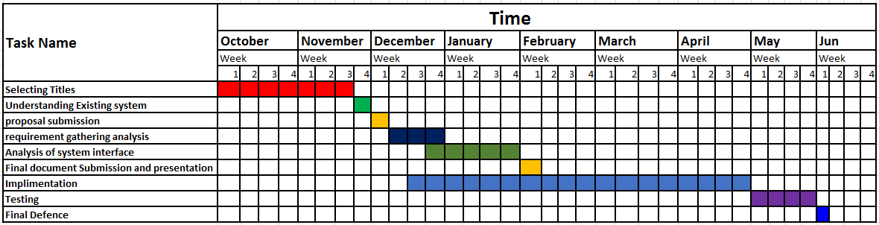

# **References**

1. 1. Vision 360 IT consulting, “Human resource management system” retrieved from <http://www.it.vision360.co.in> , last accessed in December 9, 2018.
2. 2.Abiyot Kefal , Alemayehu Demeke , Alemtsehay Bedasa , Burkitu Elias , Kidist Wendemu, “Human resource management system for sodo referral hospital” Wolaita sodo University college of natural and computational science department of computer science and IT, June 05, 2015